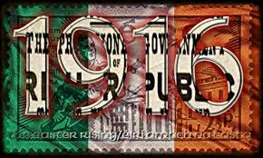

Timeline -_________________

Date and Place of Birth

Family

Education/Studies

Married life

Part played in Easter Rising 1916

How is this person remembered today?
(e.g. poems; songs; monuments..)

Death

An interesting fact you discovered as part of your studies?

List sources of information

