1916: who did what?

An Irish school teacher, a Scottish trade unionist, an aristocratic woman and a British officer were among the main players in the 1916 Rising
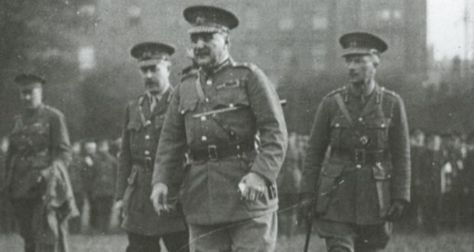
Lt General John Maxwell and his entourage inspect British troops after the Rising
Darragh Murphy

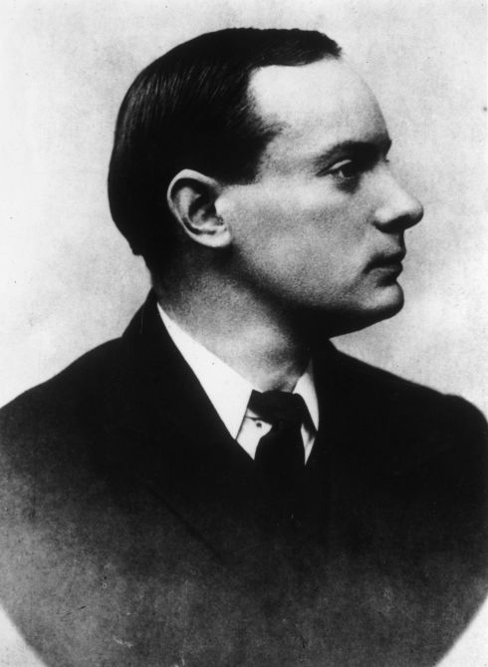

PADRAIG PEARSE
Pearse was headmaster at St Enda’s, Rathfarnham in Dublin. The finest writer and orator of the Rising (although Thomas McDonagh was the better poet), he read out the 1916 Proclamation and, as commander-in-chief, commanded the GPO garrison with James Connolly.
An arch-Catholic, he joined the IRB late, but quickly grew extreme in his thinking. He was a much better talker than fighter. Held by some to embody the “blood sacrifice” doctrine, whereby Ireland would mimic Christ by sacrificing herself to British guns, Pearse was quietly criticised by survivors for treating the rebellion as “a Greek tragedy”. He was executed on May 3rd.

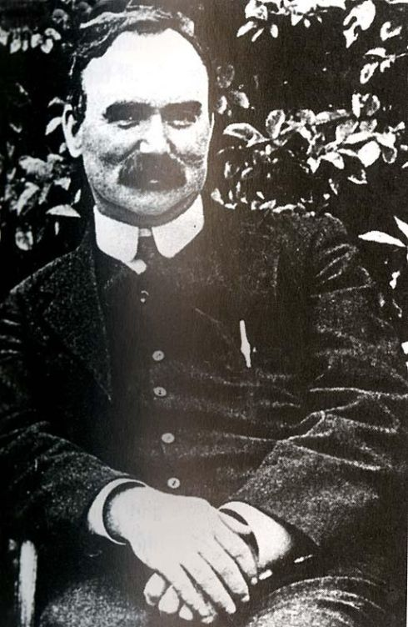

JAMES CONNOLLY
A Scottish-born socialist and trade union activist, Connolly co-founded the Irish Citizen Army to defend workers’ rights after the 1913 Lockout. In early 1916, he threatened to launch his own rebellion against the British, but was persuaded to wait until April by the IRB leaders. He was one of the seven signatories to the Proclamation and was militarily in command of the GPO garrison. He was sentenced to death but, unable to stand after being seriously injured in the fighting, he was shot while strapped to a chair in Kilmainham Gaol on May 12th.

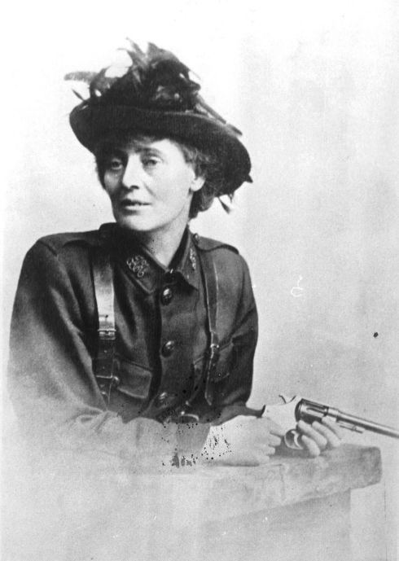

COUNTESS MARKIEVICZ
The only female leader of the 1916 Rising, Georgine Goore-Booth took her name from her 1900 marriage to the Polish Count Casimir Markievicz.
She joined the IRB and in 1909 founded Fianna Éireann, a sort of boy scouts with guns. She joined the Irish Citizens Army in 1913 and sold her jewellery to feed the poor.
In Easter 1916 she was second in command of the rebels’ Stephen’s Green garrison.
In 1918 she became the first female British MP and in 1919 the second-ever woman to become a European cabinet minister as minister for labour in the first Dáil.

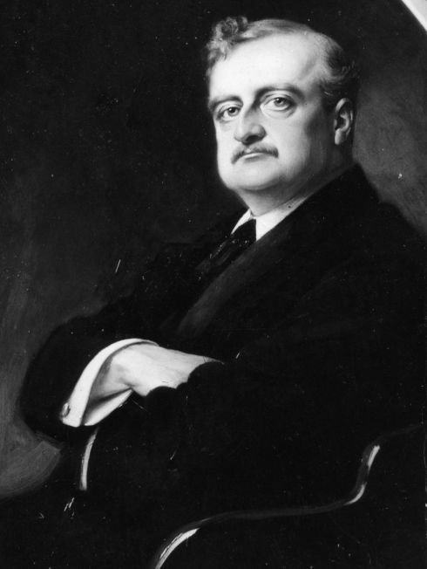

JOHN REDMOND
The 1916 Rising largely ended Irish Party leader John Redmond’s dream of Home Rule. In 1912 he persuaded the British Parliament to pass a Home Rule Bill giving Ireland limited autonomy.
Delayed after protests in Britain and Ulster, the Bill was suspended in 1914 over the first World War.
Eager to prove Ireland’s support, in 1915 Redmond led around 170,000 Irish Volunteers to form the National Volunteers. Many joined the British army.
Taken aback by the Rising and the rise of republicanism, Redmond grew ill and died in March 1918, a few months before his Irish Party were trounced in the General Election by Sinn Féin.

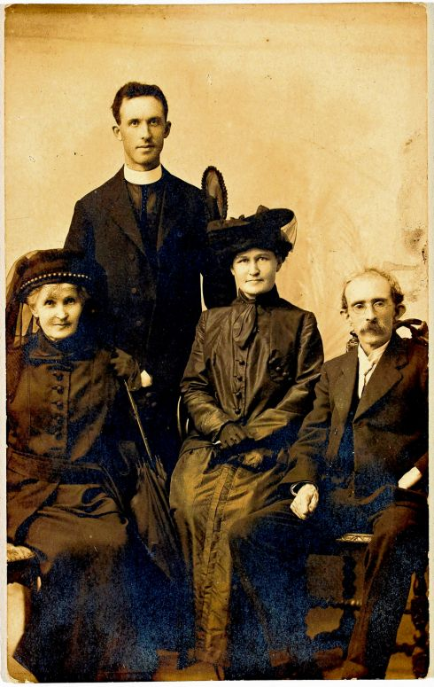

THOMAS CLARKE
The first signatory on the 1916 Proclamation was Thomas Clarke, who joined the IRB, or the Fenians, in 1878 and with his protégé Seán MacDermott effectively ran it in the run-up to the Rising.
In 1915 they formed a Military Committee to plan a rebellion, later adding Pearse, Eamonn Ceannt, Joseph Mary Plunkett, Connolly and Thomas McDonagh. Though three times the age of some Irish Volunteers, Clarke fought in the GPO throughout Easter Week. He was executed by firing squad on May 3rd, at the age of 59.

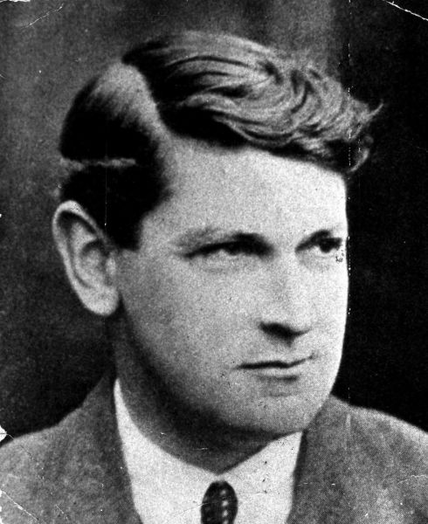

MICHAEL COLLINS
Aide-de-camp to Count Plunkett in the GPO, he fought alongside Pearse and Connolly. After the surrender, he witnessed British captain Lee-Wilson humiliate rebel prisoners by making them relieve themselves lying down. Some rebels, such as Thoomas Clarke, were forced to sleep naked in the open. Collins tried to help Clarke and took note of Lee-Wilson’s name. Collins later became IRB president and minister for finance of the first Dáil (1919). As the main figure in the War of Independence (1919-21), he had Lee-Wilson shot. Collins was chairman of the new Irish Free State provisional government and head of the Irish Army when assassinated by anti-Treaty forces in Co Cork in 1922.

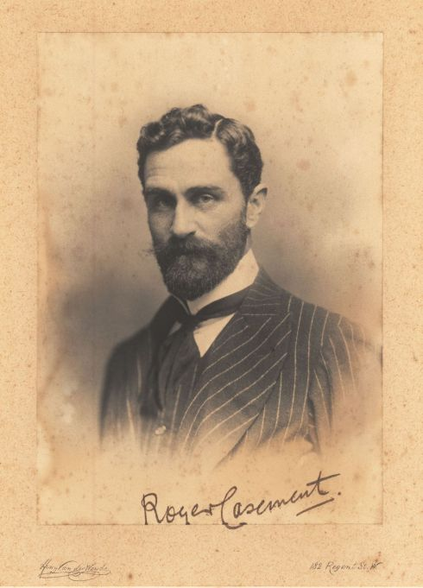

SIR ROGER CASEMENT
An Ulster Protestant knighted by Britain for exposing brutal behaviour by Europeans in Peru and the Congo, Casement joined Sinn Féin in 1905, and quit Britain’s consular service in 1913 to co-found the Irish Volunteers.
After financing the Howth gun-running, Casement met German officials at the start of the first World War, and persuaded them to give arms to the Volunteers.
The British captured the U-boat carrying the arms near Tralee, however, and Casement was arrested.
British officials used his African diaries (which contained gay references) to quell international pressure to spare him, and he was hanged in Pentonville Prison in London on August 13th.

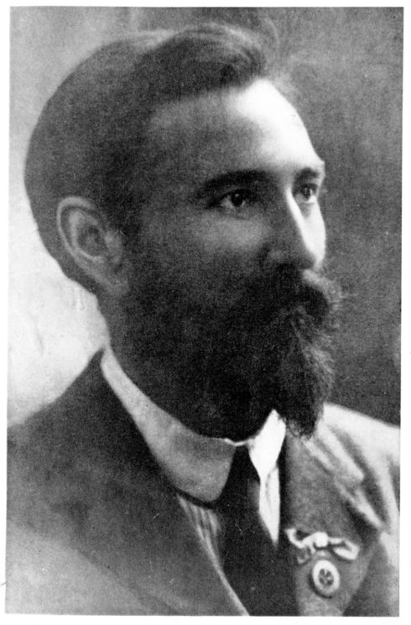

FRANCIS SHEEHY-SKEFFINGTON
A pacifist and feminist who opposed violent rebellion, Sheehy-Skeffington tried to organise a citizens’ police force to stop looting on the Tuesday of the Rising. Heading home, he was arrested in Portobello for no obvious reason by British troops.
Capt JC Bowen-Colthurst used him as a hostage while attacking the shop of Alderman James Kelly, at the top of Camden Street (now Kelly’s Corner). Bowen-Colthurst destroyed the shop with grenades, and shot dead a 17-year-old boy before marching Sheehy-Skeffington and two journalists to Portobello Barracks. They were executed the next morning.

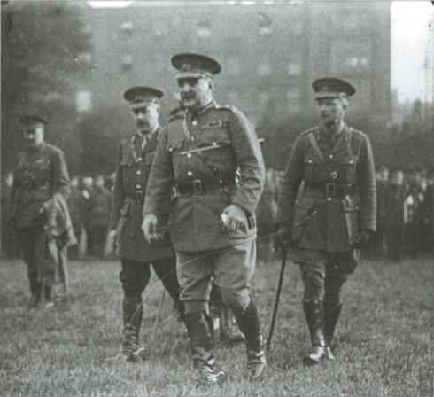

GENERAL MAXWELL
Although he served the British Army in the Sudan, in South Africa, and in the first World War, General Sir John Maxwell is best remembered for the execution of the 1916 Rising’s leaders.
After the British Government allowed the military to handle the rebels’ punishment, Maxwell was made “military governor” of Dublin and from May 2nd-9th, tried the rebel leaders by secretive field court martial – a trial without either defence lawyer or jury.
Of the 3,400 people he had arrested, 183 were tried and 90 sentenced to death. Fifteen of these were shot between May 3rd -12th.
The executions helped win sympathy for Irish independence.

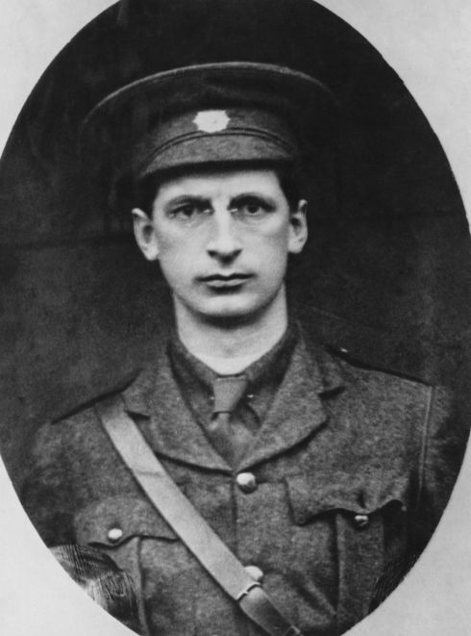

EAMON DE VALERA
In charge of rebel garrisons at Boland’s Mills, Jacob’s Factory, and around Mount Street Bridge, Cmdt De Valera saw little fighting, as the British avoided his HQ at Boland’s Bakery. He was among the last to surrender.
A maths teacher and staunch Catholic, “Dev” was born in the US to an Irish mother and escaped a death sentence after the Rising, partly due to his US citizenship. The most dominating Irish leader of the 20th century, he was president of the first Dáil (1919), and as Fianna Fáil’s first leader won five elections, 1932-1959, before becoming President of Ireland (1959-1973).

